21729 peptides were quantified in Skyline with a rdotp above 0.6.

20573 peptides were quantified in Davidek.

## Small cluster:

With applied filters 14372 are left.

Davidek shows a systematic difference of -0.01576621 in ratio, which is tiny.

98.83106 % of data points fall within 1.96 standard deviation.

**Conclusion**: There is no significant systematic error or difference between the methods.

(Filters: -10000<=m<=10000, k>0, r2>0.5). The m-filter was chosen as peptides with high absolute m-value seemed to differ a lot between the methods, and the peptide had very low ratios in the pilot Study.

When pairing davidek peptides with pilot peptides with the criteria rdotp>0.6 and 0.02<ratio<50 14587 peptides were left

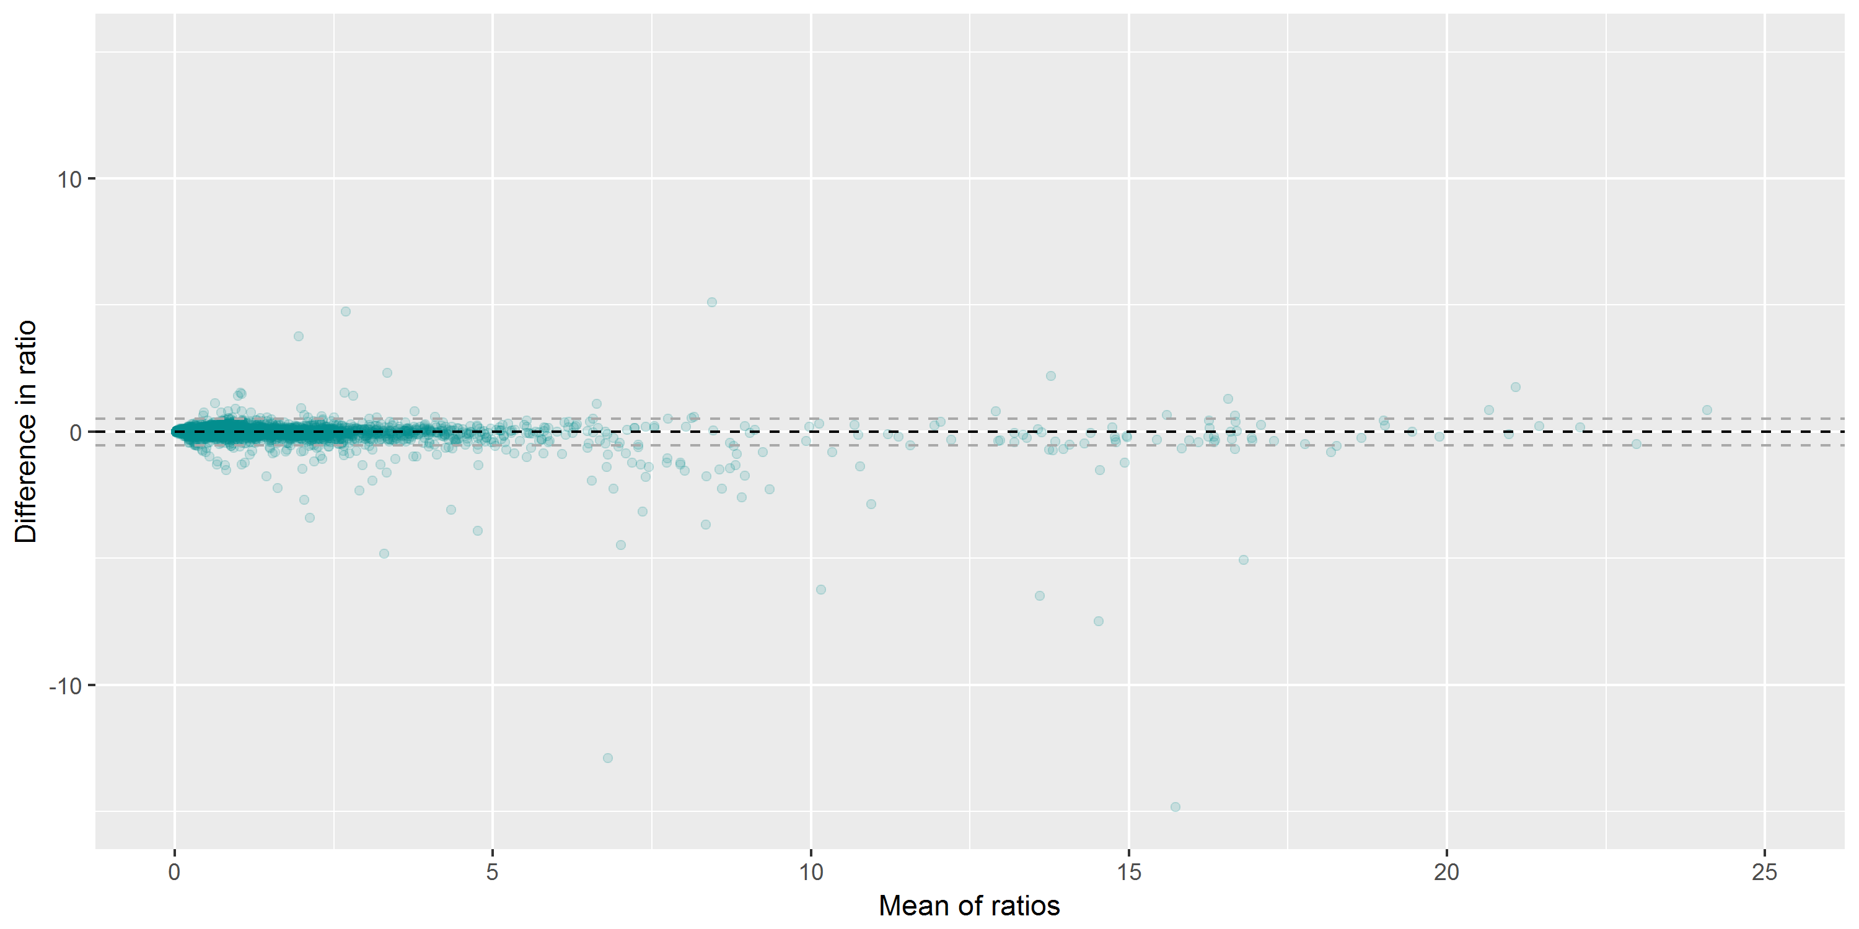

## Big cluster

With applied filters 186 are left.

OBS: All data is from DDNPNLPR++

Davidek shows a systematic difference of -10.8 in ratio.

94.0862 % of data points fall within 1.96 standard deviation.

**Conclusion**: We find significant difference between the methods and a large systematic difference. We may not want analyze at this large ratios. However, the quantification quality is also expected to be bad at large ratios and there is nothing telling us that Skyline is correct here.

The same criteria except no criteria for m-values and accepting Skyline ratios above 50.

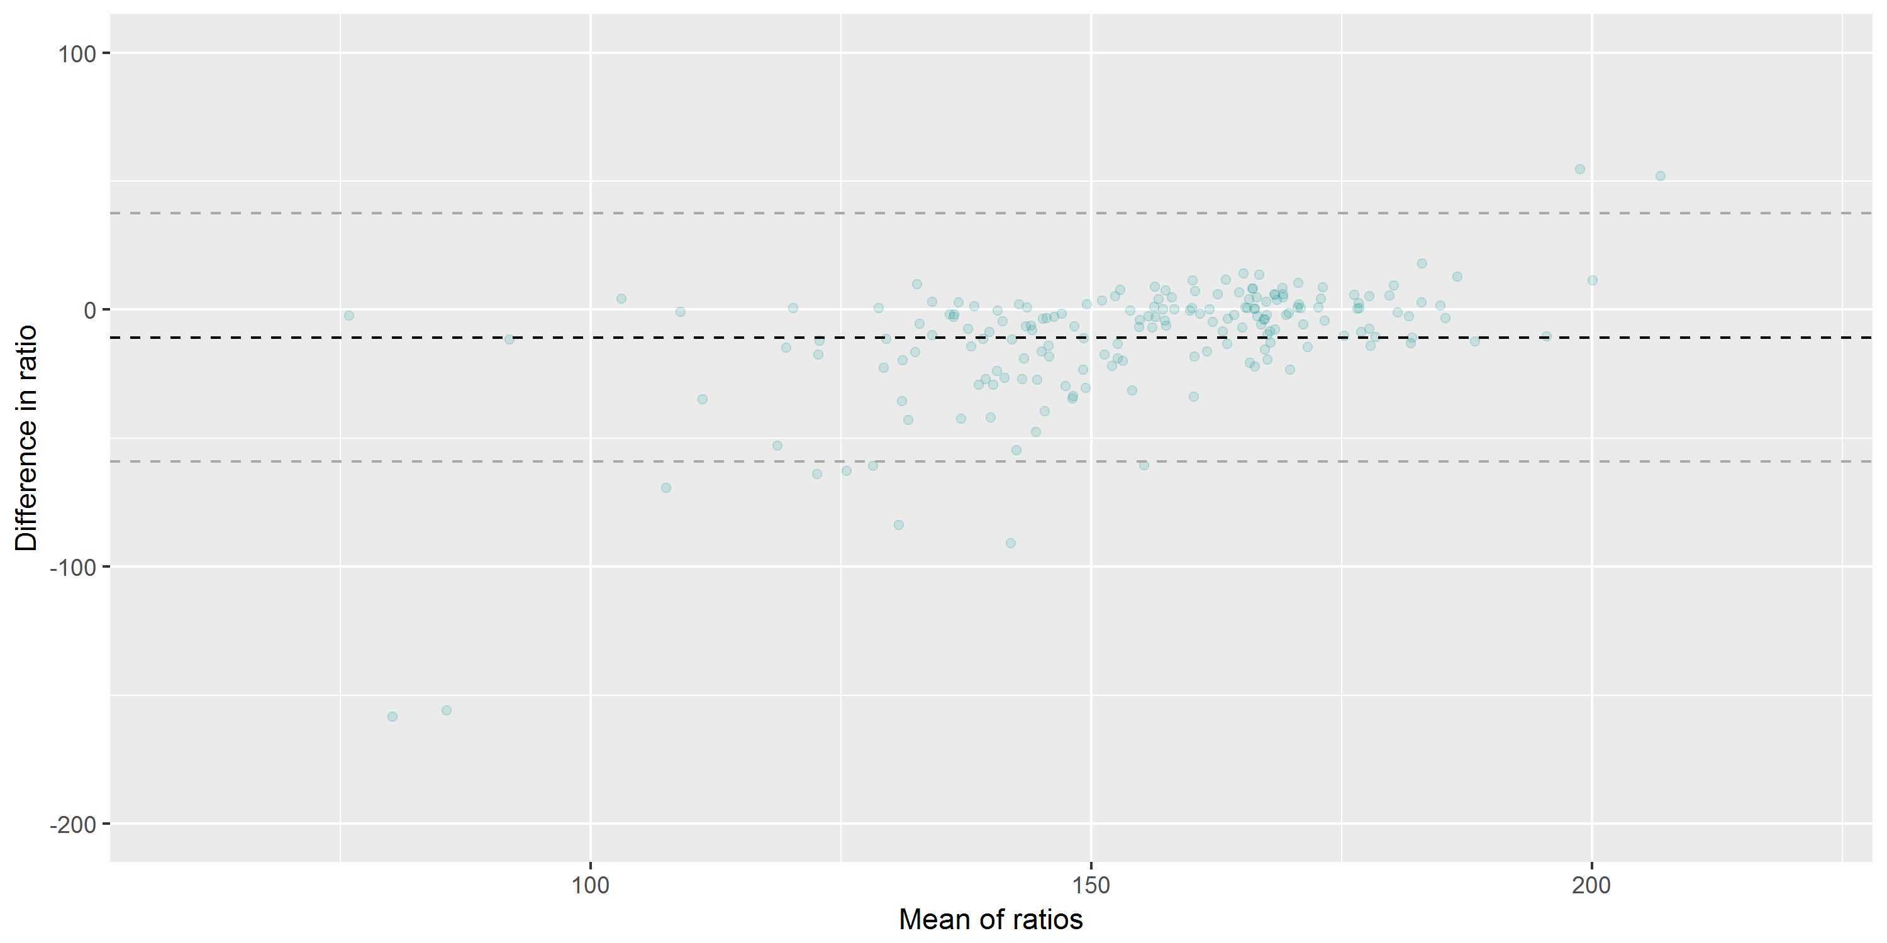

## ALL

With applied filters 17400 are left.

Davidek shows a systematic difference of -0.0937876 in ratio which is tiny.

99.31609 % of data points fall within 1.96 standard deviation.

**Conclusion:** The big variance in the big cluster increases the standard deviation and is thus misleading. I should go with the small cluster only. However, no significant difference or systematic difference could be found between the methods.

Criteria: k>0, r2>0.5, rdotp>0.6. We can see a bias where Davidek has quantified some peptides as very high ratio while Skyline has a very low ratio resulting in a straight line approximately y = -2x + 0.

